Assessing Toronto's Neighborhood to Open Chinese Restaurant

By: Atekelt K.

December 24,2019

Table of Contents

1 Introduction and Business Problem Description 3

1.1 Background 3

1.2 Business Problem Description 3

2 Data Acquisition and Cleaning 4

2.1 Data Sources 4

2.2 Data Cleaning 4

3 Methodology 4

4 Result 5

5 Discussion 10

6 Concussion 11

# Introduction and Business Problem Description

## Background

Toronto, the capital of Ontario province , is the most populated, multicultural and multiracial Canadian city. Its diversity reflected in Toronto's ethnic neighborhoods such as Chinatown, Corso Italia, Little Italy, Little India, Greektown, Koreatown, Little Jamaica, Little Portugal and Roncesvalles, which celebrate the city's multiculturalism. It is one of the most immigrant-friendly cities in North America with estimated population of just above 2.8 Million with a population density of 4,149.5 people per square kilometer (10,750/sq mi) in 2016, in which the Chinese community has taken the share of 12%. Hence, opening Chinese restaurant in Toronto can be a profitable business worth investing in.

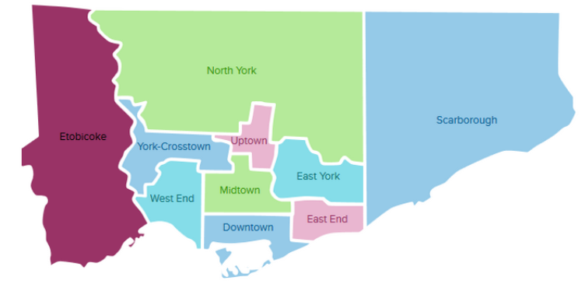

Figure 1.1 Borough of Toronto city

## Business Problem Description

It is known that Toronto shelters a greater number of Chinese and/or Chinese ancestry Canadian than any other city in Canada, it is a good idea to start the restaurant here, but we just need to make sure whether it is a profitable business or not. If so, where it can be located to yield more profit to the investor. Since there are lots of Chinese restaurants in Toronto, we need to find **locations with no Chinese restaurant in the vicinity or areas which are not already crowded with Chinese restaurants.**

Chinese population demography and existing Chinese restaurants across the neighborhoods are used as an input for identifying the most profitable location, since the success of the restaurant depends on the potential people(targeted customers) and ambience.

# Data Acquisition and Cleaning

## Data Sources

The following data sources are collectively used to solve the above stated problem

1. **Wikipedia page:** “List of Postal code of Canada: M" (https://en.wikipedia.org/wiki/List_of_postal_codes_of_Canada:_M) to get Toronto's neighborhoods information. This page has the postal code, borough and the name of all the neighborhoods in Toronto.
2. **Cvs file:** “https://cocl.us/Geospatial data” to get the geographical coordinates of the neighborhoods.
3. **Wikipedia page sources Csv file:** “Demographics of Toronto” (https://en.m.wikipedia.org/wiki/Demographics_of_Toronto#Ethnic_diversity) to get information about the distribution of population by their ethnicity. Using this page, densely populated neighborhoods with Chinese community were identified, as it might be helpful for choosing better neighborhood to open a new Chinese restaurant.
4. **Four square’s API (https://developer.foursquare.com/docs):** To get location and other information about various Chinese venues in Toronto. Using the Four square’s explore API (which gives venues recommendations), I’m fetching details about the venues up present in Toronto and collected their names, categories and locations (latitude and longitude).

## Data Cleaning

Collected data from different sources were prepared and cleaned by dropping, merging, selecting and calculating in order to make the easily analyze and visualize.

# Methodology

Important libraries were installed for pulling and preparing the required and available data ,and for analyzing and visualizing the results/outputs to select the better place to open Chinese restaurant in Toronto city. Followed by data acquisition from abovementioned sources, preparing and cleaning data so as to easily joined ,analyzed and visualized them. Data of Borough, Neighborhood, Latitude, Longitude, different ethnic population number, total restaurant in Toronto city were used for finding best location to train the model to cluster the data. The data set of Population number and restaurants number were standardized to normalize the magnitude difference.

The extracted postal codes were mapped to understand the distribution of the postal code in the city ( Figure 3.1). The postal codes are densely located around the downtown and sparsely distributed away from the downtown. 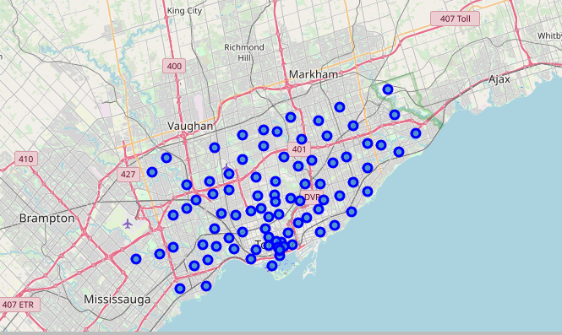

Figure 3.1 : Location map of Postal code in Toronto city, Canada

Maximum limit of 200 Venues were searched within 5000 meters from Toronto city center ( latitude=43.654,Longitude=-79.387)using Foursquare API. All available restaurants and specifically Chinese restaurants were identified for each neighborhood of the city. Followed by merging such data with geographical and demographic data.

After the data are prepared well, analysis of the available data and clustering with K-mean methods was done to identify the better place to open Chinese restaurant. The selection may be local optima (better) location, since only few influential factors were used in the model development because of data scarcity.

# Result

The analysis and modeling results revealed that 106 Chinese restaurants out of 118 totally explored Chinese restaurants are densely located at North York and Scarbought borough. Table 4-1 and Figure 4-1 are showed the characteristics of the 5 clusters and Clustered map of the city, respectively.

Table ‑ Clusters’ characteristics resulting from K-mean clustering

|  |  |  |  |  |
| --- | --- | --- | --- | --- |
| Cluster Label | Characteristics of Clusters | | | |
| Chinese population | Density (Chinese Pop/ Sq .mil) | Total restaurants | Chinese restaurants |
| Cluster 0 | [136-5,967] | [1570- 16967] | [41-56] | [0-4] |
| Cluster 1 | [160-3,500] | [1117-52656] | [27-42] | [0-3] |
| Cluster 2 | [20,996- 28,414] | [6976- 19083] | [51-60] | [3-10] |
| Cluster 3 | [8,224-17,755] | [3148 -12488] | [55-64] | [8-10] |
| Cluster 4 | [4,598-14,920] | [2775 – 26438] | [31-43] | [0-2] |

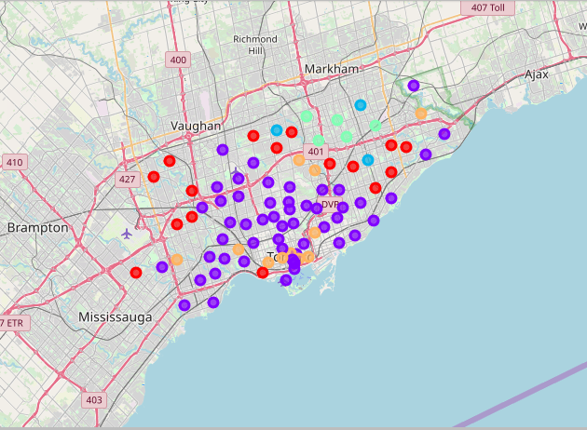

Figure ‑ Clustered map of Toronto, Canada (input: latitude, longitude ,Neighborhood ,Clustering label ,Chinese restaurants ,Chinese population). Cluster-0: **Red**, Cluster 1: **Purple**, Cluster-2: **Light Green**, Cluster -3: **Light Blue**, and Cluster-4: **Orange**

The result also showed us big Chinese Population size of 14,921 are living in **Etobicoke** Borough (Specifically at: **Cloverdale, Islington, Martin Grove, Princess** Neighborhood) but they don’t have Chinese restaurant in their vicinity ( labeled as Cluster 4). It is also in Cluster 4 , there are 10,042 Chinese population are living in **Downtown Toronto** Borough ( specifically at : **Harbourfront** Neighborhood )without having Chinese restaurant at the nearby. In comparison with others considerably larger Chinese population are living in these 2 boroughs in the absence of Chinese restaurants (Table 4-2). Hence, Cluster -4 were further analyzed to explore details ( Figure 4-2-Figure 4-4)

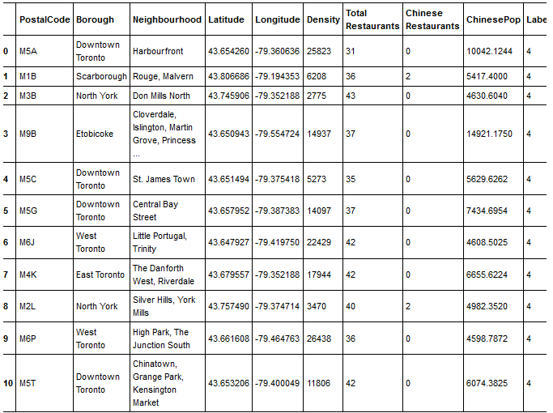Figure 4‑2 K-mean Clustering output of Cluster-4

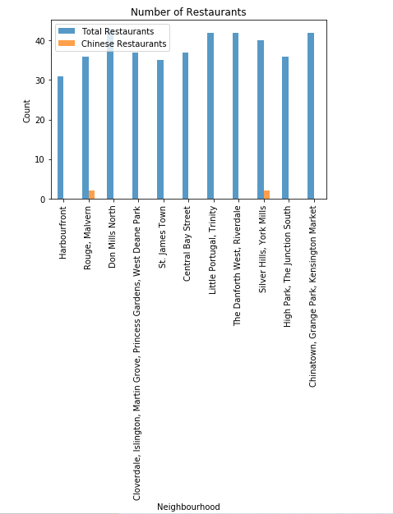

Figure ‑ Total Restaurant and Chinese Restaurants number in the neighborhoods clustered under Cluster-4

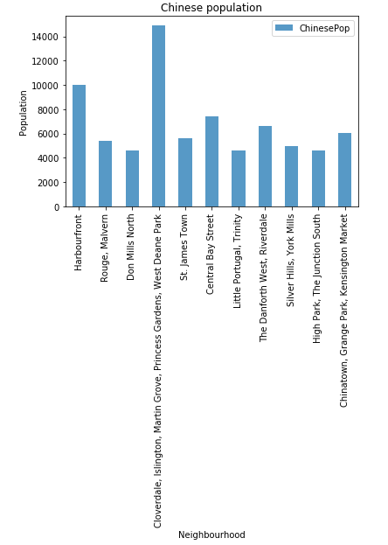

Figure ‑ Chinese population number in the neighborhoods clustered under Cluster-4

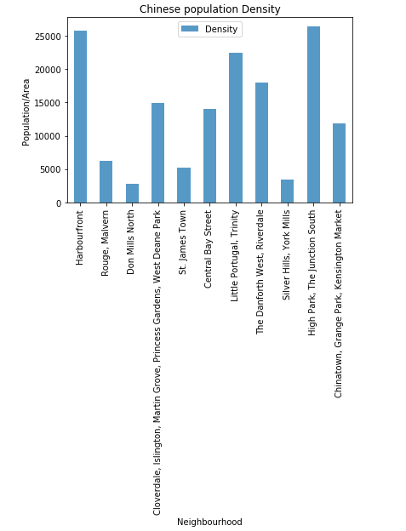

Figure ‑ Chinese population density in the neighborhoods clustered under Cluster-4

# Discussion

The clustering algorism identified two potential neighborhoods groups (Such as: 1) **Cloverdale, Islington, Martin Grove, Princess** Neighborhoods in Etobicoke borough 2) **Harbourfront** Neighborhood in **Downtown Toronto** Borough ) in Cluster 4 having considerably large and densely populated possible customers ( Chinese population ) for newly open Chinese restaurant.

There are 9 Chinese restaurants are existed at 3 different neighborhoods in **Etobicoke** borough having the Chinese population share of 6,784 (=259+559+5,966) out of the total Chinese population number of 27,085 living in the entire Etobicoke borough. The population living in those 3 neighborhoods(6,784) is less than the half of the population living in **Cloverdale, Islington, Martin Grove, Princess** Neighborhood (14,921) in the same borough. This indicate that the possible customers of the existed 9 Chinese restaurants are the Chinese population living in the nearby neighborhoods of Etobicoke borough. The ratio Chinese restaurant to of Chinese population in Etobicoke borough is 1:3009.

The total Chinese population have been living in the entire **Downtown Toronto** Borough is about 36,4250 in 11 neighborhoods (880+950+1435+1135+835+350+1660+10042+5630+ 7434+6074) without a Chinese restaurant. Such big Chinese community in the entire Downtown Toronto Borough is a fertile business opportunity for investors to open Chinese restaurant at one of the neighborhoods, specifically **Harbourfront** Neighborhood with 10,042 Chinese population is the best.

# Concussion

Finding the best location to open Chinese restaurant is required more input data that influence the success of the business. This exercise shows the general workflow necessary to choose a best location for Chinese restaurant. From the result , I concluded that generally **Downtown Toronto** Borough, specifically **Harbourfront** Neighborhood is the best location for the investors to open a Chinese restaurant.